And………….STOP!
Educational Robotics
SPIRIT Lesson Building Block Template

Author: Sara Tingelhoff
Grade: Targeted at Grade 3
Date: November 20, 2007

- Concepts Covered

Mathematics

- Measurement in inches, feet, and yards
- Using estimation

- Applicable Standards

Mathematics

* Measurement: Apply appropriate techniques, tools, and formulas to determine
measurement

* Estimation:

3)Learning Activity Context (Description of the Learning Activity)

Context: X Moving TekBot __ Building a TekBot __ Programming a TekBot

Description: Students will use a finished TekBot to complete this lesson. The students will use the introductory information that they learned about inches, feet and yards to estimate given distances to drive the TekBot. After they estimate how far they think they need to drive it to make the distance, students will use measuring tapes to determine how close their estimation was or was not.

- Teacher and Student Suggestions/Tips

  - Students will draw a distance from the stack of cards that contain a variety of measurements using inches, feet and yards.

  - Students will estimate how far they believe the distance to be by driving the TekBot.

  - Students will then measure the distance that they drove the TekBot to determine how accurate their estimate was. Students will measure the distance from behind the back tires at the start to the back tires at the finish.

- Teacher Questions

      - How accurate do you think you will be when you drive the TekBot?
      - What strategies did you use to ensure that your estimate was accurate?

- Recording Data Ideas

    - Students will use a recording sheet to write the distance they chose on a card, the distance they drove the TekBot and the difference between the two.

- Materials:

TekBot recording sheet pencil

Measuring tapes rulers yard sticks

Long sheet of paper

- Student Templates or Worksheets:

Data Documentation

This table can be used for the students to organize their data and record each trial.

Distance on Card | Distance Driven | Difference
19 inches | 27 inches | 8 inches
3 yards (36 inches) | 22 inches | 14 inches
4 feet (48 inches) | 55 inches | 7 inches
64 inches | 37 inches | 27 inches

Extensions:

Use the TekBot to explore perimeter.

Give the students a perimeter. Example: 13 ft.

Have the students attempt to drive the TekBot around in a shape design. Mark where it began and each time the TekBot turns, mark where it turned, until it creates a closed plane figure. Measure the distance between each point to see how close their estimate was to the perimeter they started with.

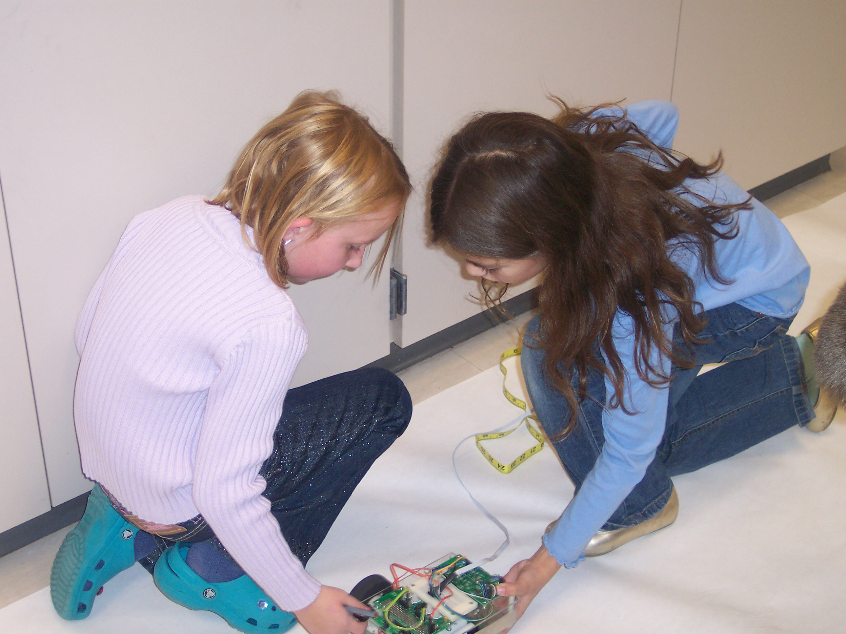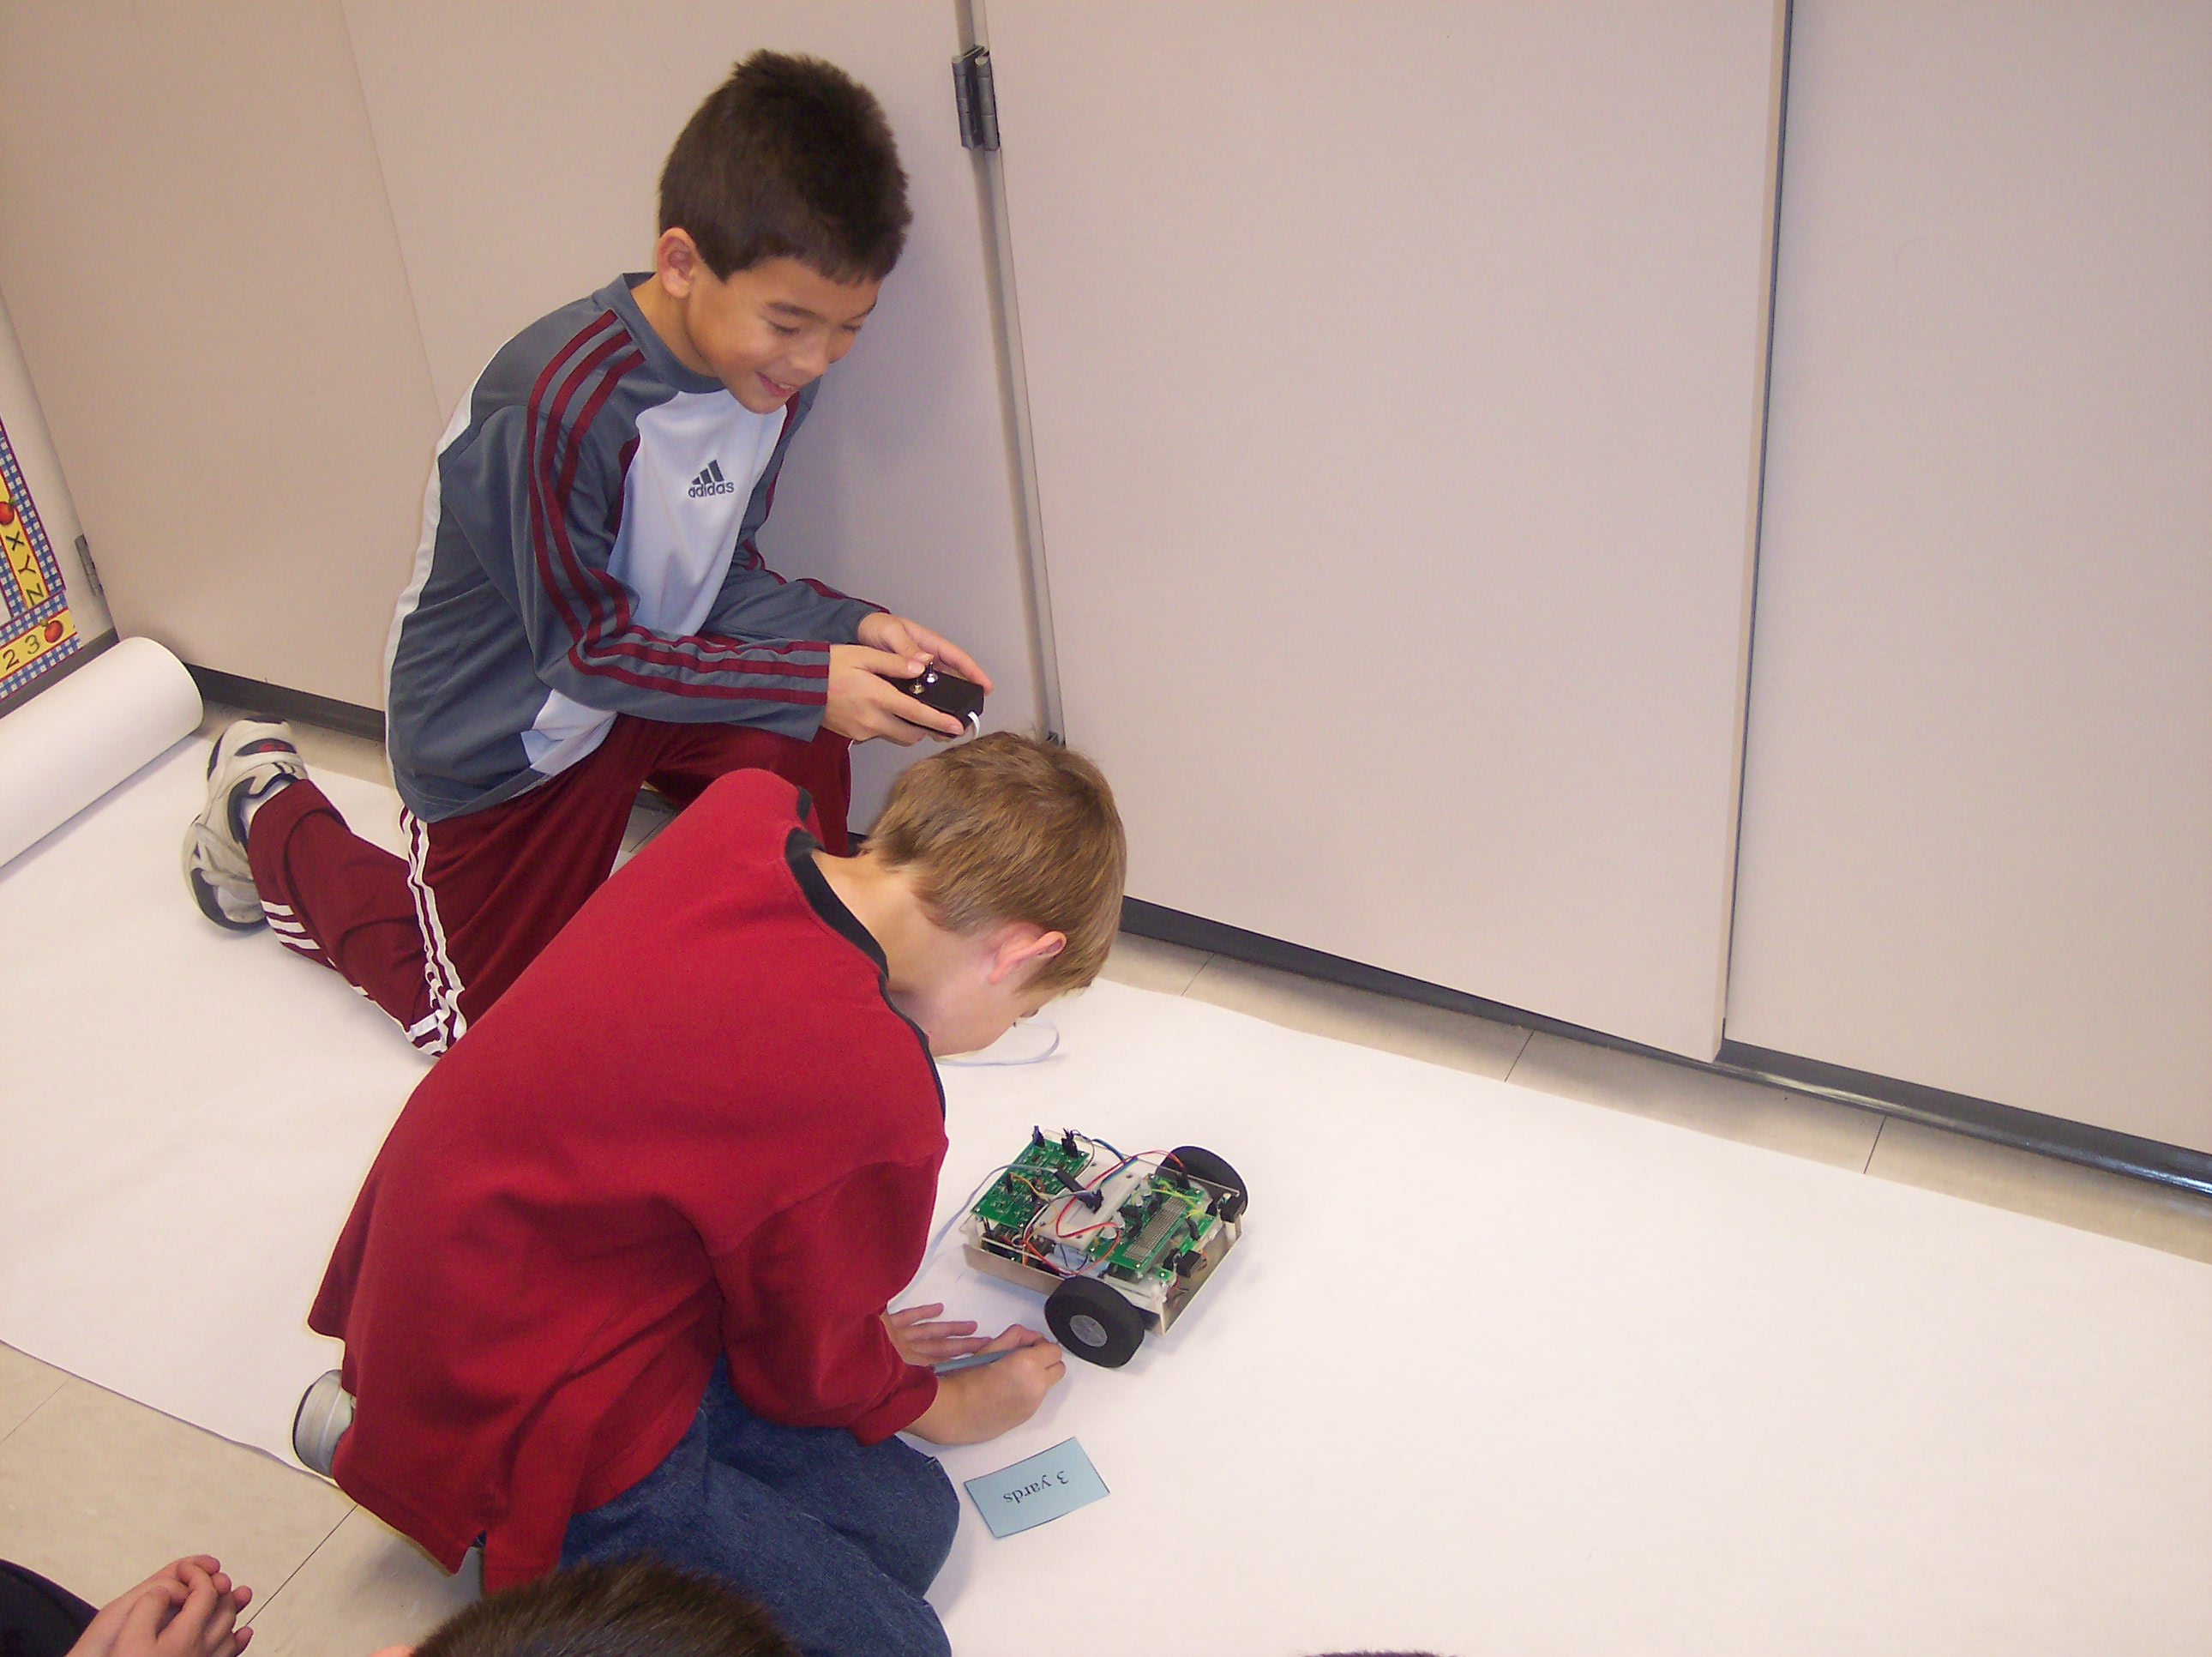

Students getting the TekBot ready. Marking the starting point.

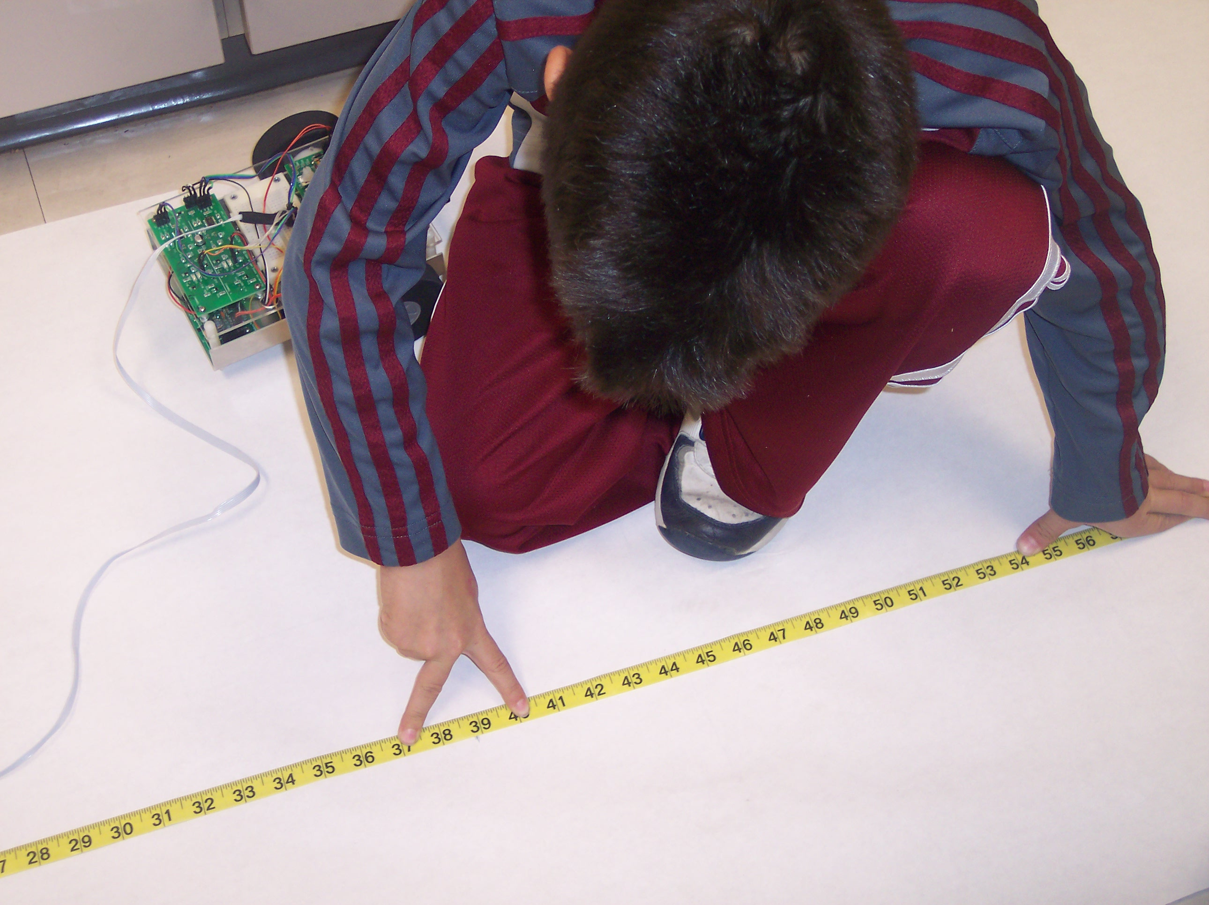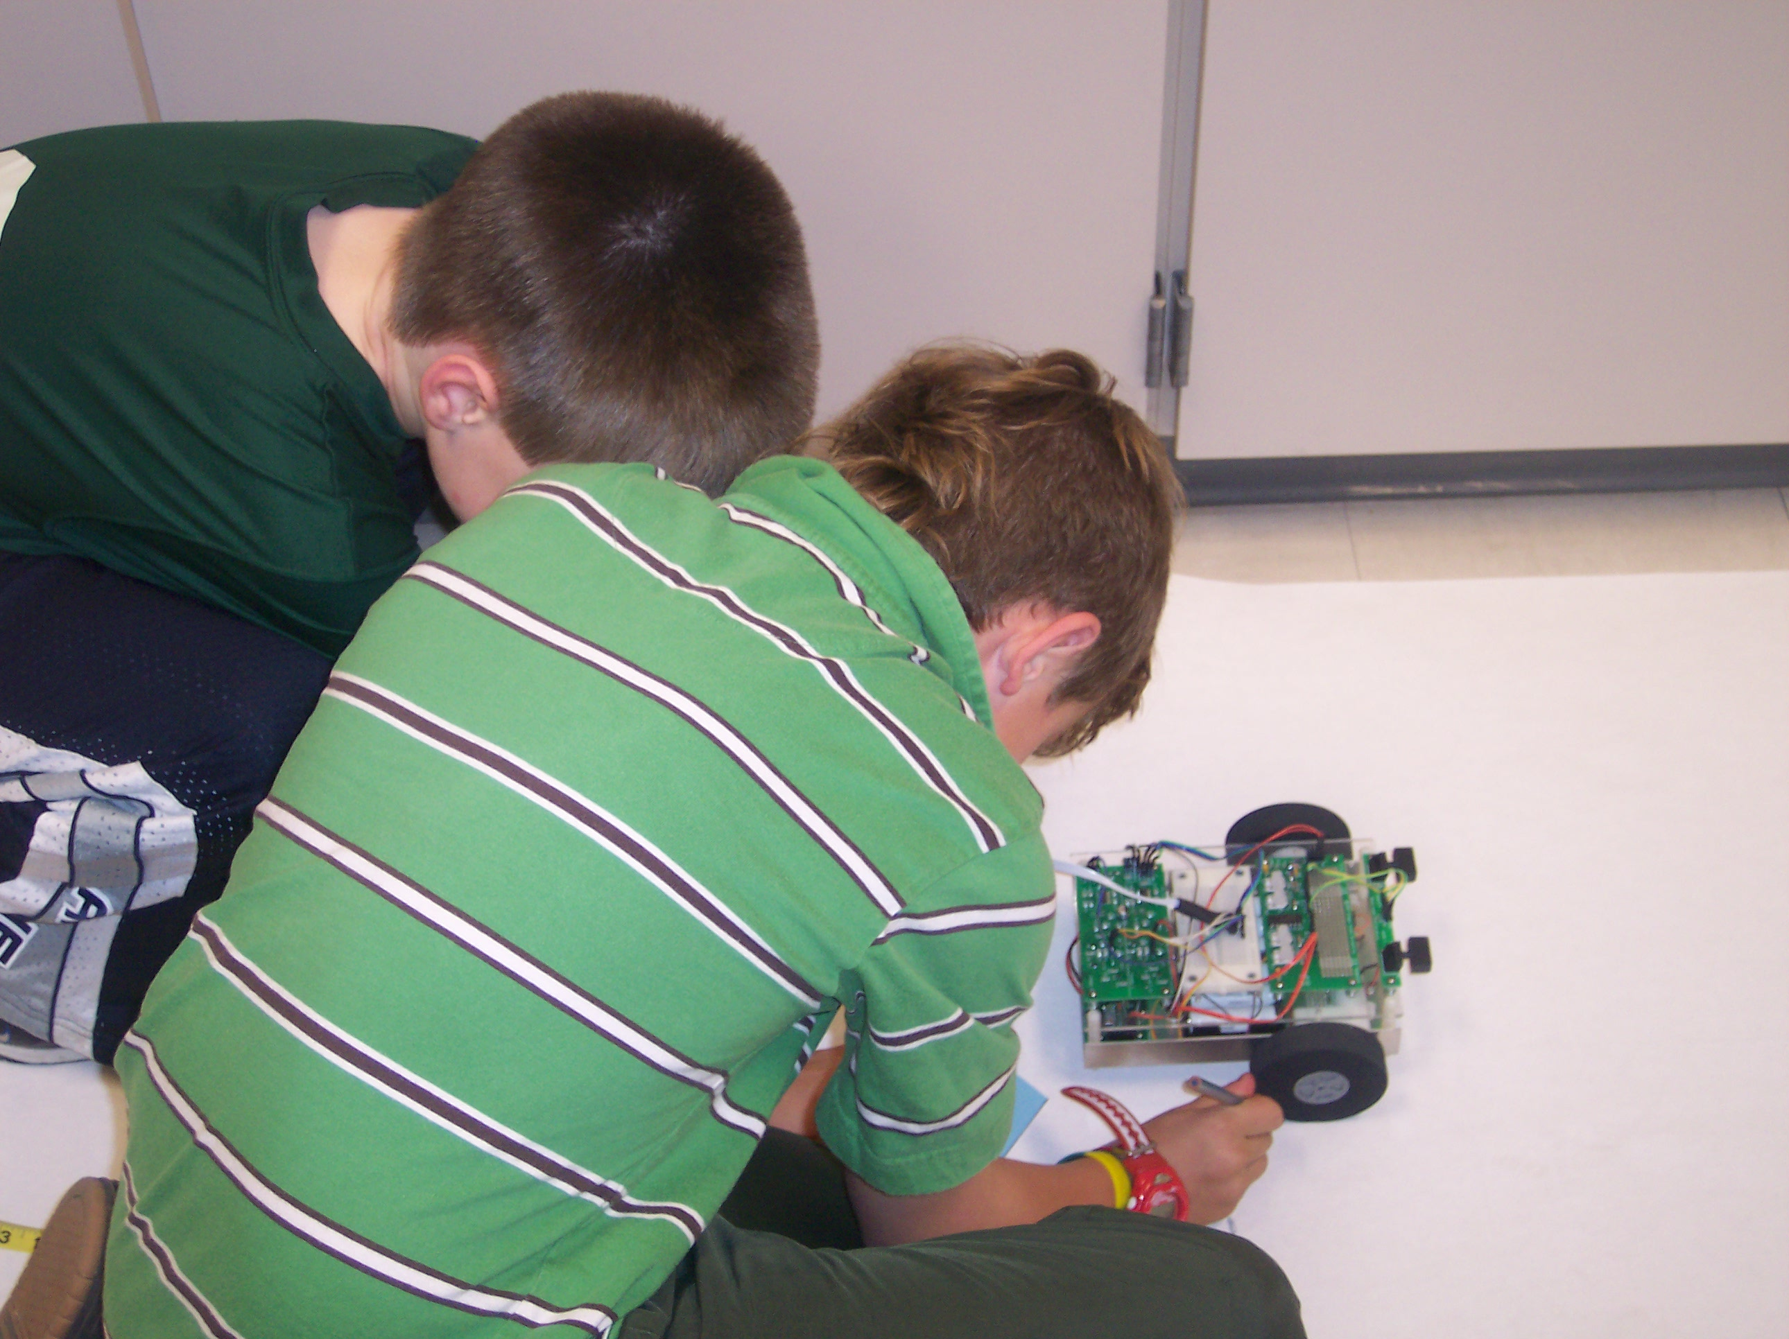

Measuring the distance driven. Marking the ending point.

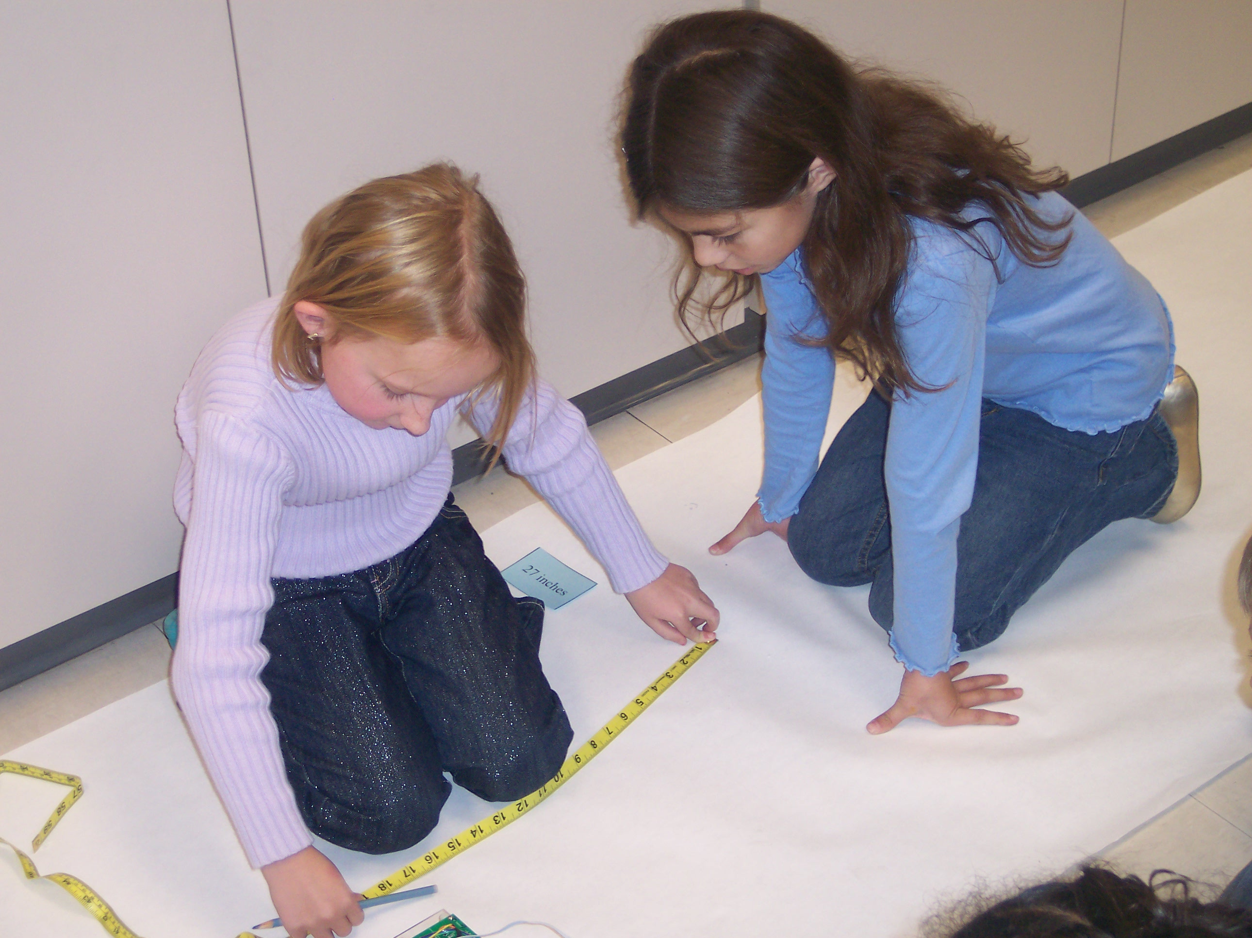

Measuring the distance driven.

