SPIRIT 2.0 Lesson:
Cell Me What?

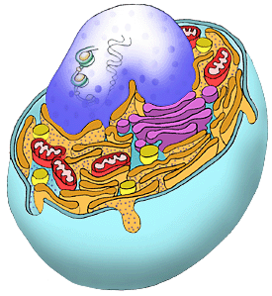
==========================Lesson Header ==========================
Lesson Title: Cell Me What?
Draft Date: July 17, 2008
1st Author (Writer): Jason Rhine
2nd Author (Editor/Resource Finder):
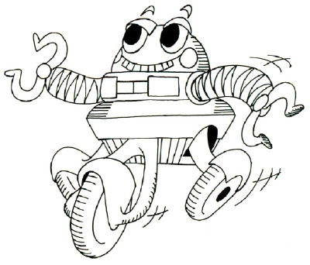
Algebra Topic:
Grade Level: Middle or Secondary
Cartoon Illustration Idea: Cell and Robot side by side for comparison

Outline of Lesson

Content (what is taught):
- Concept of functions of eukaryotic (plant or animal) cellular organelles.
- Concept of characteristics of eukaryotic cellular organelles.
- Relationship between differing organelles that facilitate cellular organization.
Context (how it is taught):
- Students will investigate the organelles of eukaryotic cells; including functions, and responsibilities.
- Students will investigate the structure of the CEENbot; parts and functions.
- Students will create an analogy between the CEENbot and a eukaryotic cell using three column notes and a graphical image (poster).

Activity Description:
In this lesson students will discover the structure, function and organization of organelles with the eukaryotic cell, while at the same time explore the structure, function and organization of the CEENbot. By comparing the functions within each item students will obtain an appreciation of HOW the bot and cell work, while getting a deeper understanding of the component parts by using the analogy “My Cell is like my CEENBot because ________. “ To this end, students should create a page with three columns; first labeled “Cell Part”, second labeled “Function/Job” and finally the third labeled “CEENbot Part”. After completing the three column notes, students will graphically show their results with a labeled poster of the CEENbot with the cell parts indicated below the CEENbot label in parenthesis. Finally, there will be an oral defense of the choices made to check for understanding. Students will have the opportunity to defend their choices by explaining why the paired those two parts and why.

Standards: (At least one standard each for Math, Science, and Technology - use standards provided)

Math Science Technology
E1, E2, B1 A1, A2, C1, C5 A1, A3, D3

Materials List:
Classroom Robot Animal Cell Diagram Plant Cell Diagram Poster Paper Markers/Colors
Notebook Paper Textbook Chalkboard/Whiteboard Writing Materials

ASKING Questions (Cell Me What?)
Summary: Students are asked how a robot and a cell are alike.

Outline:
- Breakdown the parts of the robot by function/job.
- Examine cell organelles for function / job.
- View diagrams of them both.

Activity:
Place diagrams of both CEENbot and a eukaryotic cell on the overhead, LCD projector or board. Breakdown the parts of each with appropriate functions.

Questions | Possible Answers
- Why would we use an analogy when teaching?  - How are machines and cells alike? | So we can use something we know very well and apply it to something we don’t know at all.  Movement, specific functions, memory, programmable, etc.
- How are machines and cells different? | Non-living vs. living, fragile vs. sturdy, artificial vs. natural, etc.
- If you had to describe a robot without using some key words like metal, plastic, circuit, board or robot/machine, what would you say? | Answers will vary. This is an exploratory activity where students should be allowed to express their creativity.
- What can you observe between both items? | That at basic functional components there are parts that do the same jobs. They are not in the same locations, but do equally the same work.

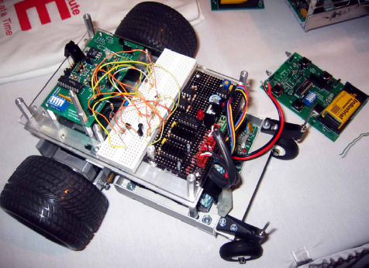
EXPLORING Concepts (Cell Me What?)
Summary: Students are asked how a robot and a cell are alike.

Outline:
- Use a basic analogy to illustrate the compatibility of two disparate objects.
- Allow students to brainstorm suggestions between the robot and eukaryotic cell.

Activity:
Demonstrate the basic analogy; i.e. A cell is like a school (below is a partial list)

Cell Part | Function | School Part
Nucleus | Control center of the cell; regulates and controls internal functions and structures | The Principal
Nuclear Envelope | Membrane surrounding the nucleus; controls what enters and leaves the nucleus | The Main Office
Lysosomes | Areas that contain enzymes for the removal/destruction of worn out parts, waste or intruders within the cell | Custodial Staff
Mitochondria | “Powerhouse of the cell” Site where chemical energy is created through cellular respiration and the breakdown of glucose for use | School Boiler or Electrical Room

Image Idea: Eukaryotic cell diagrams along with schematics of CEENbot and whatever else you would like to use for the initial analogy.
INSTRUCTING Concepts (Cell Me What?)

Note: The instructing concepts section will be provided by the instructional writing team. The final instructing content section may look different from the one shown below. This sample is provided here so that this sample lesson shows all A, E, I, O and U components.

Summary: Instructor will demonstrate how two seemingly different objects can actually have similar functions, specifically using cells and another well known item.

Outline:
- Individual breakdown of each organelle part/function
- Individual breakdown of each CEENbot part/function

Activity:
Take a schematic of both the eukaryotic cell and the CEENbot and go step by step thought each of the parts that the instructor deems required for comprehension. Go over shape of the organelle, their locations, their functions and the overall purpose of them present within the cell. Repeat with the CEENbot.
Allow students to make choices by which they equate CEENbot parts to cellular organelles.
Finally, allow students to show their choices by a poster and using the three column notes to justify their choices of analogous parts.
ORGANIZING Learning (Cell Me What?)
Summary: Students will organize themselves with two visual representations of what they have decided to use within their analogies.

Outline:
- Three column notes for organization
- Poster for reinforcement and visual learning

Activity:
Students will create three column notes for their analogous parts and a poster for visual representation.

Worksheet Idea: Three Column Notes as seen below. Cell Parts under investigation should be listed for the students within the first column so the teacher knows all content will be explored.

Cell Part | Function | CEENbot Part
Nucleus | Control center of the cell; regulates and controls internal functions and structures
Nuclear Envelope | Membrane surrounding the nucleus; controls what enters and leaves the nucleus
Lysosomes | Areas that contain enzymes for the removal/destruction of worn out parts, waste or intruders within the cell
Mitochondria | “Powerhouse of the cell” Site where chemical energy is created through cellular respiration and the breakdown of glucose for use
Etc.
UNDERSTANDING Learning (Cell Me What?)
Summary: Students write essays about the distance-rate-time formula and how it can be used to investigate the rate of motion (speed).

Outline:
- Formative assessment of eukaryotic cellular organelles
- Summative assessment of cells

Activity:

Formative Assessment
Oral defense of choices made for the analogy. If they understand the functions of the organelles, then they should be able to defend their choice within the classroom.

Summative Assessment
- Students will complete an exam with multiple parts including; multiple choice, short answer, fill in the blank, matching and graphical representations of cellular parts, functions and characteristics.

