Teresa Faris “SPIRIT” Workshop Lesson Unit

I. Prior knowledge: Powers of Ten
Anticipatory Set: Complete the chart.

10 6 10 5 10 4 10 3 10 2 10 1 10 0 10 -1 10 -2 10 -3 10 -4 10 -5 10 -6
1 1 1 1 1 1 10 1 10 2 10 3 10 4 10 5 10 6
1,000,000 100,000 10,000 1,000 100 10 1 1 1 1 1 1 1 10 100 1,000 10,000 100,000 1,000,000
0.1 0.01 0.001 0.0001 0.00001 0.000001
(6 zeros) (5 zeros) (4 zeros) (3 zeros) (2 zeros) (1 zero) (0 zeros) (1 zero) (2 zeros) (3 zeros) (4 zeros) (5 zeros) (6 zeros)
- x 10 6 1.0 x 10 5 1.0 x 10 4 1.0 x 10 3 1 .0 x 10 2 1.0 x 10 1 1.0 x 10 0 1.0 x 10 -1 1.0 x 10 -2 1.0 x 10 -3 1.0 x 10 -4 1.0 x 10 -5 1.0 x 10 -6

Scientific Notation: Web site http://www.nyu.edu/pages/mathmol/textbook/scinot.html

II. Lesson: Electronics Part II: Resistors

III. Content Standards: PA 08: Apply the mathematics in this class to solve relevant real-life problems.
PA 01: Convert values among fractions, decimals, and percents.

IV. Learning Activity Context: Context: ____ Moving Tekbot Pre-build Building a Tekbot X Engineering/ Notebook ____ other
Abstract: 1. Students will review prior knowledge, then apply those skills to the resistor unit.
(Note: Students need to be able to read a resistor before they can use them to build a Tekbot.)
- Resistors are passive electronic components used to limit current on circuit boards. Students will need to determine the value of resistance(in ohms) as well as their manufacturing tolerance of individual resistors by reading the color coded strips.
- Students will create their own mnemonic to remember the color sequence. (Review: Pemdas mnemonic)
- Students will practice reading resistors in small groups, then compete in board races for practice assessment.

Teacher and Student suggestions/ Tips: To help them remember the first color of the sequence - remind them that BLACK and
ZERO have NOTHING in common.

- Teacher Questions: 1. The teacher walks around the room with picture color cards -asks student the resistor and tolerance values.
- If a resistor has a large manufacturing tolerance( say +/- 20) is the manufacturer allowing a bigger or smaller window of imperfection on the assembly line?
- Name a strip on a resistor 1st, 2nd, 3rd, or 4th - students will identify it as the 1st digit, 2nd digit, multiplier, or tolerance.
(The fifth band refers to the quality band)
- Body colors white and blue are used to mark non-flammable and fusible resistors.
(Non-flammable resistors and fusible resistors are designed so that they don't catch fire when
they overheat. When fusible resistor overheats it cuts the current flowing like a fuse. Do not replace
these fuses with regular fuses - they could cause a fire if something goes wrong in the circuit.)
- Assessment Ideas: 1. Peer quizzes in small groups using flash cards
2. Memory card game
3. Board game (Capture the Crown-board races)
- Pencil paper quiz from pictures
- Have students create their own 3-dimensional resistor
Other information: Web page for Resistor Calculations: (4 Band, 5 Band, 6 Band)
http://samengstrom.com/nxl/3660/4_band_resistor_color_code_page.en.html A.

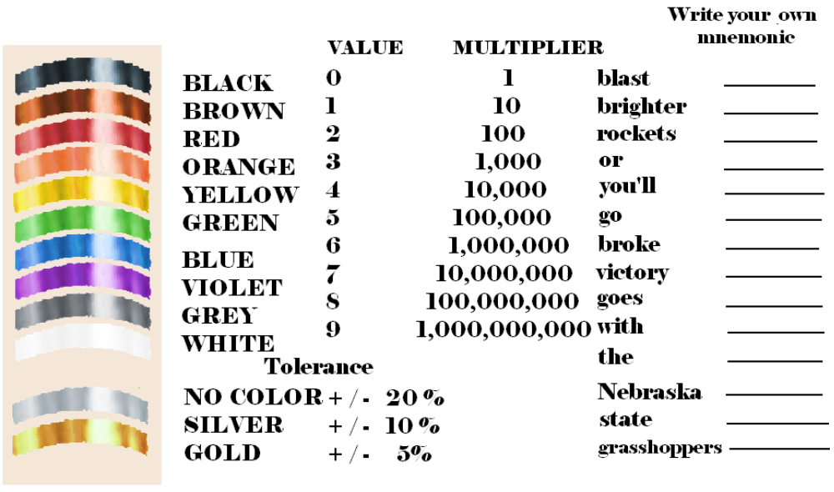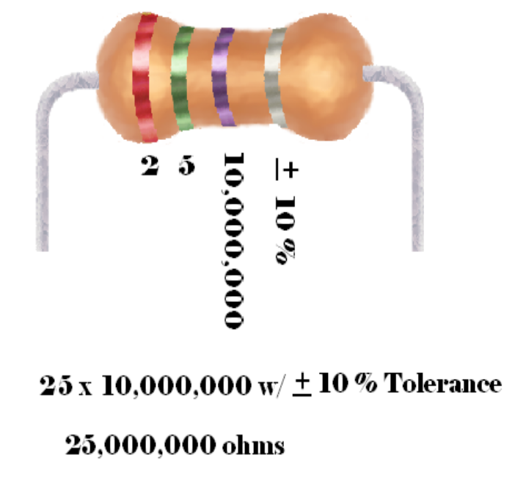
- What is the tolerance range for this resistor? _____________ to ____________
- Application: Aim for the Stars at UNO.

- The Lesson was presented to first group of students.
- Students calculated the ohms for the resistors installed on their Tekbots.
3. They used their multi-meters to check their work.

